IdahoSTARS RISE Crosswalk
- Register on RISE to access the trainings listed on this crosswalk https://rise.idahostars.org/#/signup (if you do not have a RISE account)
- Once you are logged in you will be able to search using the # listed in the crosswalk below to find the training you’d like to complete. Please note the column Format in RISE (options: online, live, or TTA)
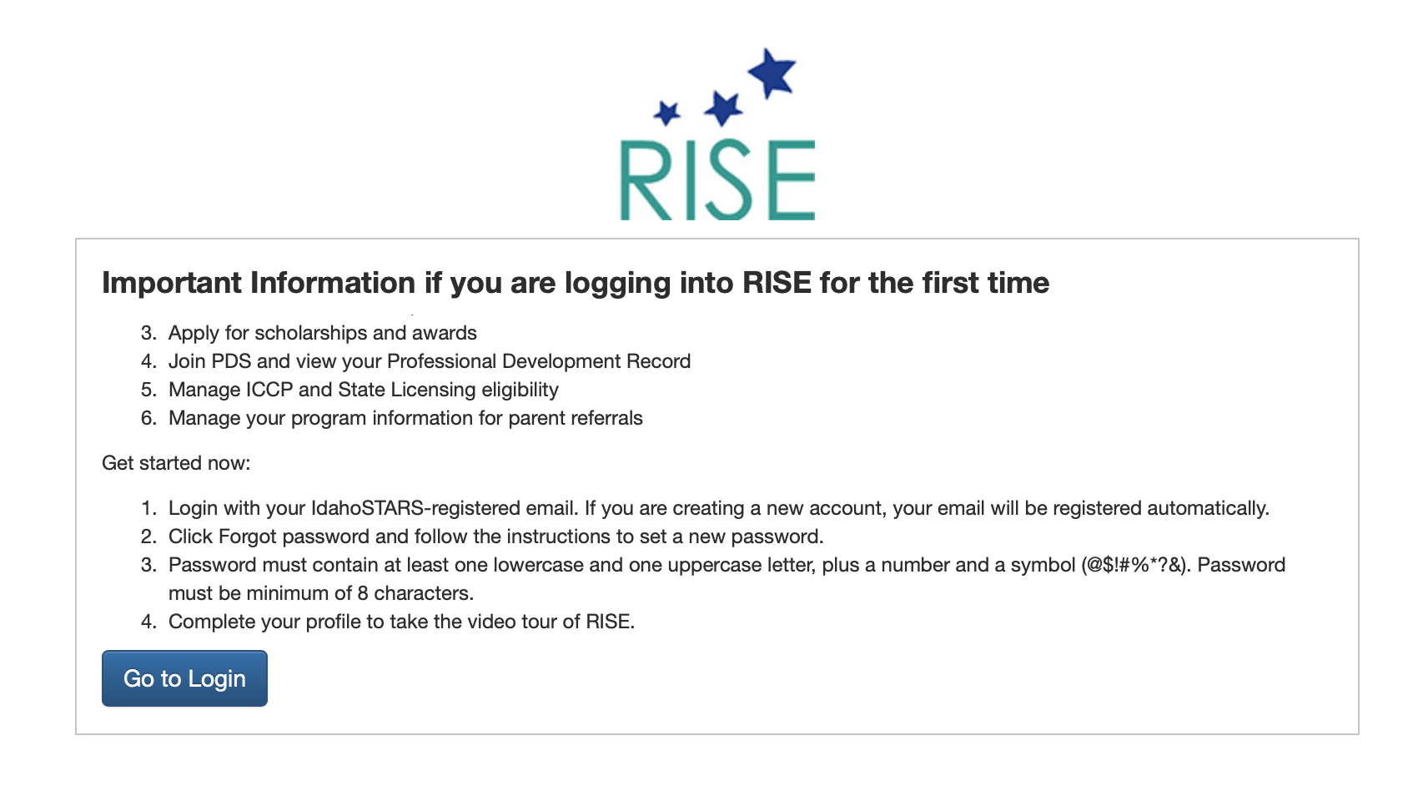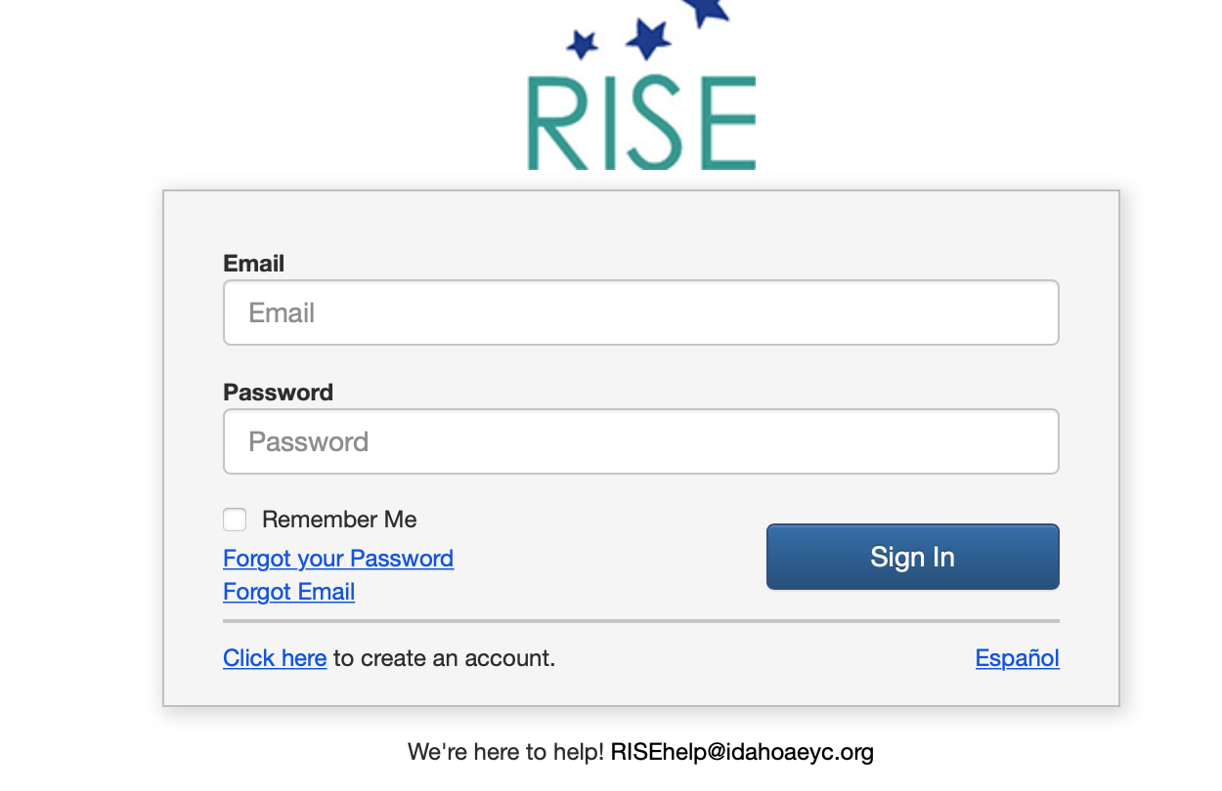
- Track what you have done
  - If you printed the crosswalk place an “x” in the completed column on the right side of the document for each of the trainings you completed
  - You can simply “click” in the and it will mark it with an X for each completed training.
  - Add the total hours completed on the crosswalk and enter where indicated the last page

- Save or Scan your crosswalk
  - If you used the crosswalk as a fillable form you can then save it as a PDF to your computer for uploading in the next step
  - If you printed the crosswalk to track your training you will need to scan it as a PDF before you can upload it to EASy

- Add your crosswalk in EASy
  - Log into your EASy application
  - Go to the Education tab and at the bottom of the page click on
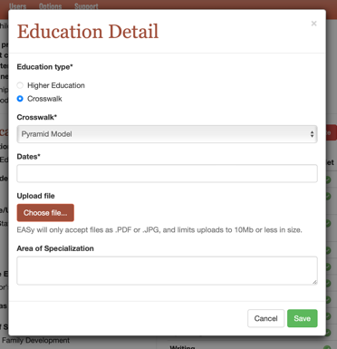
  - Select “Crosswalk”

  - Select IdahoSTARS RISE
  - Enter the date range you completed the trainings
  - Upload your copy of the crosswalk (EASy will only accept .PDF or .JPG files so you will need to save your crosswalk in one of those formats before you upload it)
  - Click on the GREEN save button when done and proceed to step #5

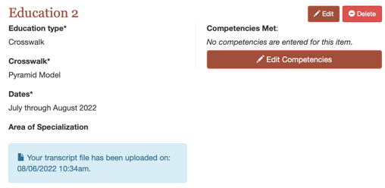
- Click on the “Edit Competencies” button

- Click in the box under “met” for those marked on your crosswalk
  - When you click on the + sign it opens the competency, the – closes the competency
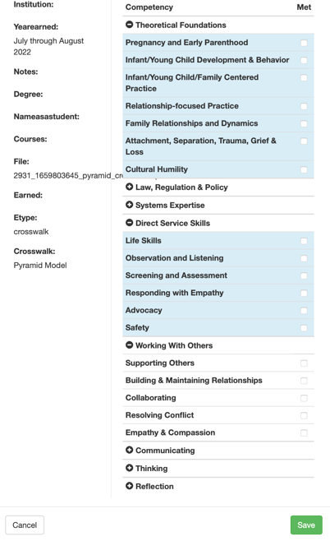
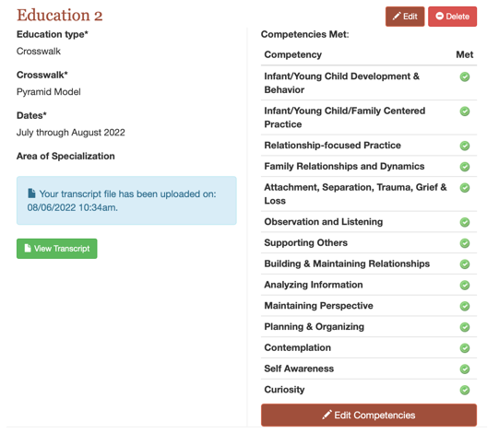
Make sure you click the GREEN save button!!
When you’ve saved your entry it will look something like this

Completed (X) | IdahoSTARS trainings  RISE CROSSWALK | Module | Hours | Format  In RISE | Competencies covered
☐ | Trauma-Informed Care & the Pyramid Module – Module 1 (305) | 1 | 2 | Online | attachment, separation, trauma, grief & loss  self-awareness
☐ | Trauma-Informed Care & the Pyramid Module – Module 2 (306) | 2 | 1.5 | Online | infant/young child development & behavior
☐ | Trauma-Informed Care & the Pyramid Module – Module 3 (307) | 3 | 1.5 | Online | relationship-focused practice
☐ | ePyramid Birth – 5, Module 1: Building Relationships and Creating Supportive Environments (367)  (English/Spanish) | 1 | 6 | Online | maintaining perspective  infant/young child development & behavior  family relationships & dynamics  attachment, separation, trauma grief, & loss  supporting others  contemplation
☐ | ePyramid Birth – 5, Module 2: Social Emotional Teaching Strategies (368)  (English/Spanish) | 2 | 6 | Online | maintaining perspective  relationship-focused practice  infant/young child development & behavior  infant/young child & family-centered practice  observation & listening  self-awareness
☐ | ePyramid Birth – 5, Module 3: Individualized Intervention (369)  (English/Spanish) | 3 | 6 | Online | maintaining perspective  infant/young child development & behavior  building & maintaining relationships  planning & organizing  analyzing information  curiosity
☐ | Preschool ePyramid Package: Module 1, Building Relationships and Supportive Environments (659) | 1 | 6 | Online | maintaining perspective  building & maintaining relationships  contemplation  planning & organizing  observation & listening  family relationships & dynamics
☐ | Preschool ePyramid Package: Module 2, Social Emotional Teaching Strategies (660)  *additional training needed specific to birth to 36 months | 2 | 6 | Online | observation & listening  infant/young child development & behavior*  planning & organizing  building & maintaining relationships  maintaining perspective  self-awareness
ENTER THE TOTAL THE NUMBER OF TRAINING HOURS for this PAGE:
Complete (X) | IdahoSTARS trainings | Module | Hours | Format  In RISE | Competencies covered
☐ | Preschool ePyramid Package: Module 3, Individualized Intervention (661)  *additional training needed specific to birth to 36 months | 3 | 6 | Online | maintaining perspective  collaborating  infant/young child development & behavior*  analyzing information  observation & listening  planning & organizing
☐ | ePyramid Infant Toddler – Module 1: Social Emotional Development in the Context of Relationships (408) | 1 | 6 | Online | maintaining perspective  infant/young child development & behavior  family relationships & dynamics  attachment, separation, trauma grief, & loss  supporting others  contemplation
☐ | ePyramid Infant Toddler – Module 2: Responsive Routines, Environments, and Targeted Strategies (409) | 2 | 6 | Online | relationship-focused practice  infant/young child development & behavior  infant/young child & family-centered practice  family relationships & dynamics  observation & listening  self-awareness
☐ | ePyramid Infant Toddler – Module 3: Individualized Intervention (410) | 3 | 6 | Online | maintaining perspective  infant/young child development & behavior  building & maintaining relationships  planning & organizing  analyzing information  curiosity
☐ | Addressing Challenging Behaviors, Module 1: Promoting Social and Emotional Health in Young Children (509) | 1 | 3 | Online | infant/young child development & behavior  attachment, separation, trauma & loss  supporting others
☐ | Addressing Challenging Behaviors, Module 2: Promoting Social and Emotional Health in Young Children (510) | 2 | 3 | Online | observation & listening  building & maintaining relationships  analyzing information
☐ | Addressing Challenging Behaviors, Module 3: Promoting Social and Emotional Health in Young Children (511) | 3 | 2 | Online | self-awareness  family relationships & dynamics
☐ | Addressing Challenging Behaviors, Module 4: Promoting Social and Emotional Health in Young Children (512) | 4 | 3 | Online | planning & organizing  exercising sound judgment  resolving conflict
ENTER THE TOTAL THE NUMBER OF TRAINING HOURS for this PAGE:
Complete (X) | IdahoSTARS trainings | Module | Hours | Format  In RISE | Competencies covered
☐ | The Heart of Infant & Toddler Care, Lesson One: Everything Begins with Relationships (392) | 1 | 1 | online | infant/young child & family-centered practice
☐ | The Heart of Infant & Toddler Care, Lesson Two: Personal Care Routines - Infants (393) | 2 | 1 | online | exercising sound judgement
☐ | The Heart of Infant & Toddler Care, Lesson Three: Personal Care Routines - Toddlers (396) | 3 | 1 | online | exercising sound judgement
☐ | The Heart of Infant & Toddler Care, Lesson Four: The Developing Infant (399) | 4 | 1 | online | observation & listening
☐ | The Heart of Infant & Toddler Care, Lesson Five: The Developing Toddler (400) | 5 | 1 | online | observation & listening
☐ | Reducing Implicit Bias (370) |  | 2 | online | cultural humility  maintaining perspective
☐ | ET: Preventing Children from Getting Hurt & Responding to Suspected Child Abuse or Neglect (345)  (English/Spanish) |  | 2 | online/ live | government law & regulation  safety
☐ | ET: Infant Development: Physical, Cognitive, Language & Communication, Social & Emotional (550)  (English/Spanish) |  | 1.5 | online | infant/young child development & behavior
☐ | ET: Toddler Development: Physical, Cognitive, Language & Communication, Social & Emotional (549)  (English/Spanish) |  | 1.5 | online | infant/young child development & behavior
☐ | ET: Preschool Age Child Development: Physical, Cognitive, Language & Communication, Social & Emotional (628)  (English/Spanish) *does not fully meet infant/young child development & behavior |  | 2 | online | infant/young child development & behavior*
☐ | ET: Safe, Appropriate, and Engaging Outdoor Environments (552)  (English/Spanish) |  | 2 | online/ live | government, law & regulation  safety
☐ | ET: Safe & Healthy Sleep (609)  (English/Spanish) |  | 2 | online/ live | agency policy  safety
☐ | ET: Supporting Early Brain Development (406)  (English/Spanish) *does not fully meet Pregnancy & Early Parenthood |  | 1 | online/ live | pregnancy & early parenthood*
☐ | WIC: Beyond the Grocery Store (476)  *does not fully meet Pregnancy & Early Parenthood |  | 1 | online | community resources  pregnancy & early parenthood*
☐ | ACEs 1.0: Trauma, Violence and ACEs (478)  (English/Spanish) |  | 3 | live | attachment, separation, trauma, grief & loss  professional/personal development  maintaining perspective
ENTER THE TOTAL THE NUMBER OF TRAINING HOURS for this PAGE:
Complete (X) | IdahoSTARS trainings | Module | Hours | Format  In RISE | Competencies covered
☐ | ACEs 2.0: Hope in Caring for and Educating Children Affected by Trauma (480)  (English/Spanish) |  | 3 | live | attachment, separation, trauma, grief & loss  family relationships & dynamics  advocacy
☐ | Introduction to Responsive Relationships, Supportive Environments, and Behavior Guidance for Young Children (334) |  | 2 | live | infant/young child & family-centered practice  planning & organizing
☐ | Introduction to the ASQ-3 (348) |  | 3 | live | screening & assessment  analyzing information  maintaining perspective
☐ | An Introduction to Strengthening Families: A Protective Factors Framework (405)  (English/Spanish) |  | 2 | online | responding with empathy  life skills
☐ | Strengthening Families (567)  (English/Spanish) |  | 3 | live | infant/young child & family centered practice  responding with empathy  building & maintaining relationships
☐ | Sharing Leadership, Partnering with Parents (528)  (English/Spanish) |  | 3 | live | infant/young child & family-centered practice  collaborating  advocacy
☐ | Responsible Adults, Safe Children (513)  (English/Spanish) |  | 3 | live | safety  life skills  ethical practice
☐ | Committing to Strengthening Families (526)  (English/Spanish) |  | 3 | live | self-awareness  planning & organizing  personal/professional development
☐ | Do No Harm (620)  (English/Spanish) |  | 2 | online/ live | agency policy  government, law, & regulation
☐ | Sharing is Caring: How to share your knowledge of ACEs, brain development and the power of positive experiences (503) |  | 2 | live | relationship-focused practice  supporting others
☐ | Lunch Box Mealtime Basics: Healthy and Safe Lunch Contents and Quality Lunch Box Policies (593) |  | 2 | live | government, law & regulation  agency policy
☐ | Professionalism 1.0 (572) |  | 2 | live | ethical practice  life skills
☐ | Professionalism and Ethics in Child Care (571)  (English/Spanish) |  | 1 | online | ethical practice
☐ | Environment Rating Scales: A Tool for Quality Improvement (546)  (English/Spanish) *does not fully meet Screening & Assessment |  | 1 | online | screening & assessment*
ENTER THE TOTAL THE NUMBER OF TRAINING HOURS for this PAGE:
ENTER THE TOTAL THE NUMBER OF TRAINING HOURS for this PAGE:
Complete (X) | IdahoSTARS trainings | Module | Hours | Format  In RISE | Competencies covered
☐ | More About the Environment Rating Scale (ERS) ECERS-3 & ITERS-3 (589)  (English/Spanish) *does not fully meet Screening & Assessment |  | 1 | online | screening & assessment*
☐ | Tools for Screening and Developmental Monitoring in Child Care (663)  (English/Spanish) |  | 2 | online/  live | agency policy  service delivery systems
☐ | Introduction to High Quality Early Childhood Inclusion (372)  (English/Spanish) |  | 2 | online | government, law & regulation  agency policy
☐ | Children Who Are Dual Language Learners (451)  (English/Spanish) |  | 1 | online | cultural humility
☐ | Choose Safe Places and Drinking Water Testing for Child Care (309)  (English/Spanish) |  | 1 | online | community resources
☐ | I got my ERS results… now what?!? Using ERS results as a tool in Continuous Quality Improvement (381) |  | 2 | live | screening & assessment  solving problems
☐ | Understanding Trauma and its impact on Early Learning (308) |  | 2 | live | attachment, separation, trauma, grief & loss  empathy and compassion
☐ | The Role of Child Care Providers in Idaho’s Early Intervention Services (441) (English/Spanish) |  | 1.5 | online | service delivery systems  agency policy
☐ | Incorporating Activities into Child Care Routines to Promote Children’s Oral Health (440) (English/Spanish) |  | 1 | online | community resources
☐ | Building Positive Relationship with Children Through Therapeutic Encounters/Engaging Interactions TTA |  | 3 | TTA | analyzing information  relationship-focused practice  building & maintaining relationships
☐ | Self-Care and Self-Reflection in the Workplace TTA |  | 2 | TTA | self-awareness  maintaining perspective
☐ | Using ASQ-3 with Families in your Program TTA |  | 3 | TTA | screening & assessment  analyzing information  solving problems
☐ | Supporting Dual Language Learners (DLLs) and Promoting English Learning TTA |  | 2 | TTA | ethical practice  cultural humility
☐ | Active Supervision TTA |  | 3 | TTA | observation & listening  analyzing information  exercising sound judgement

Complete (X) | IdahoSTARS trainings | Module | Hours | Format  In RISE | Competencies covered
☐ | Brain Research and Its Implications for Early Childhood Programs TTA |  | 2 | TTA | infant/young child development & behavior  solving problems
☐ | Building Spaces, Finding Words to Support Positive Guidance TTA |  | 2 | TTA | relationship-focused practice  responding with empathy
☐ | Classroom Design and the Physical Environment TTA |  | 4 | TTA | infant/young child development & behavior  planning & organizing  observation & listening  contemplation
☐ | Emotional Literacy TTA |  | 4 | TTA | infant/young child development & behavior  emotional response  ethical practice  self-awareness
☐ | Nurturing and Responsive Relationships TTA |  | 3 | TTA | relationship-focused practice  building & maintaining relationships  empathy & compassion
☐ | Supporting Social Emotional Skills in the Classroom: Self-Awareness and Emotional Regulation TTA |  | 3 | TTA | supporting others  self-awareness  responding with empathy
☐ | Schedules and Routines TTA |  | 3 | TTA | infant/young child development & behavior  family relationships and dynamics  life skills
☐ | Transitions TTA |  | 3 | TTA | infant/young child development & behavior  supporting others  maintaining perspective
☐ | Pyramid Module 1, Part 1- Promoting Children’s Success: Building Relationships (442) |  | 2 | live | building & maintaining relationships  family relationships & dynamics
☐ | Pyramid Module 1, Part 2- Promoting Children’s Success: Creating Supportive Environments (444) |  | 1 | live | planning & organizing
☐ | Pyramid Module 1, Part 3- Promoting Children’s Success: Schedules, Routines, & Transitions (455) |  | 2 | live | maintaining perspective  contemplation
☐ | Pyramid Module 1, Part 4- Promoting Children’s Success: Giving Directions and Teaching Classroom Rules (471) |  | 1 | live | supporting others
☐ | Pyramid Module 2, Part 1- Teaching Social Emotional and Friendship Skills (482) |  | 2 | live | relationship-focused practice  building & maintaining relationships
☐ | Pyramid Module 2, Part 2- Teaching Emotional Literacy, Self-Regulation, and Problem-Solving Skills (497) |  | 2 | live | infant/young child development & behavior  planning & organizing
ENTER THE TOTAL THE NUMBER OF TRAINING HOURS for this PAGE:
Complete (X) | IdahoSTARS trainings | Module | Hours | Format  In RISE | Competencies covered
☐ | Pyramid Module 2, Part 3- Focusing on Individualized Supports and Partnering with Families (502) |  | 2 | live | infant/young child & family-centered practice  family relationships & dynamics
☐ | Pyramid Module 3, Part 1- Intensive Intervention: What is Challenging Behavior? (613) |  | 3 | live | infant/young child development & behavior  analyzing information  maintaining perspective
☐ | Pyramid Module 3, Part 2- Intensive Intervention: Developing a Behavior Support Plan (619) |  | 3 | live | planning & organizing  observation & listening  collaborating
☐ | Caring for the Caregiver (472) |  | 2 | online/ live | emotional response  self-awareness
☐ | The ZERO TO THREE Critical Competencies for Infant-Toddler Educators™ Area 1 Micro-Course: Supporting Social-Emotional Development – SE-1 Building Warm, Positive, and Nurturing Relationships |  | 3 | live | relationship-focused practice  cultural competence  attachment, separation, trauma, grief & loss
☐ | The ZERO TO THREE Critical Competencies for Infant-Toddler Educators™ Area 1 Micro-Course: Supporting Social-Emotional Development – SE-2 Providing Consistent and Responsive Caregiving |  | 3 | live | relationship-focused practice  responding with empathy  advocacy
☐ | The ZERO TO THREE Critical Competencies for Infant-Toddler Educators™ Area 1 Micro-Course: Supporting Social-Emotional Development – SE-3 Supporting Emotional Expression and Regulation |  | 3 | live | infant/young child development & behavior  maintaining perspective  life skills
☐ | The ZERO TO THREE Critical Competencies for Infant-Toddler Educators™ Area 1 Micro-Course: Supporting Social-Emotional Development – SE-4 Promoting Socialization |  | 3 | live | infant/young child development & behavior  self-awareness  analyzing information
☐ | The ZERO TO THREE Critical Competencies for Infant-Toddler Educators™ Area 1 Micro-Course: Supporting Social-Emotional Development – SE-5 Guiding Behavior |  | 3 | live | infant/young child development & behavior  solving problems  planning & organizing
☐ | The ZERO TO THREE Critical Competencies for Infant-Toddler Educators™ Area 1 Micro-Course: Supporting Social-Emotional Development – SE-6 Promoting Children’s Sense of Identity and Belonging |  | 3 | live | exercises sound judgement  listening  curiosity
☐ | The ZERO TO THREE Critical Competencies for Infant-Toddler Educators™ Area 2 Micro-Course: Supporting Cognitive Development – C-1 Facilitating Exploration and Concept Development |  | 3 | live | maintaining perspective  analyzing information  curiosity
☐ | The ZERO TO THREE Critical Competencies for Infant-Toddler Educators™ Area 2 Micro-Course: Supporting Cognitive Development – C-2 Building Meaningful Curriculum |  | 3 | live | screening and assessment  observation & listening  planning & organizing
ENTER THE TOTAL THE NUMBER OF TRAINING HOURS for this PAGE:

Complete (X) | IdahoSTARS trainings | Module | Hours | Format  In RISE | Competencies covered
☐ | The ZERO TO THREE Critical Competencies for Infant-Toddler Educators™ Area 2 Micro-Course: Supporting Cognitive Development – C-3 Promoting Imitation, Symbolic Representation, and Play |  | 3 | live | relationship-focused practice  infant/young child development & behavior  cultural humility
☐ | The ZERO TO THREE Critical Competencies for Infant-Toddler Educators™ Area 2 Micro-Course: Supporting Cognitive Development – C-4 Supporting Reasoning and Problem Solving |  | 3 | live | solving problems  analyzing information  exercises sound judgement
☐ | The ZERO TO THREE Critical Competencies for Infant-Toddler Educators™ Area 3 Micro-Course: Supporting Language and Literacy Development – L&L-1 Promoting Communication Exchange |  | 3 | live | infant/young child development & behavior  responding with empathy  life skills
☐ | The ZERO TO THREE Critical Competencies for Infant-Toddler Educators™ Area 3 Micro-Course: Supporting Language and Literacy Development – L&L-2 Expanding Expressive and Receptive Language and Vocabulary |  | 3 | live | speaking  cultural humility  attachment, separation, trauma, grief & loss
☐ | The ZERO TO THREE Critical Competencies for Infant-Toddler Educators™ Area 3 Micro-Course: Supporting Language and Literacy Development – L&L-3 Promoting Early Literacy |  | 3 | live | relationship-focused practice  maintaining perspective  analyzing information
☐ | Spreading HOPE: Healthy Outcomes from Positive Experiences, the Role of Child Care Providers |  | 1 | online/ live | advocacy
☐ | Basics of Food, Nutrition, and Mealtimes (397) |  | 2 | live | safety  observation and listening
☐ | Basics of Active Physical Play (398) |  | 2 | live | government, law & regulation  safety
☐ | Childhood Food Insecurity (470) |  | 1 | online | cultural humility
ENTER THE TOTAL THE NUMBER OF TRAINING HOURS for this PAGE: and then TOTAL ALL PAGES:

